  Fare Prognosis

Report submitted in partial fulfilment of the requirement for the

degree of

B.Tech.

In

###### Computer Science & Engineering

By

##### **Aanya Srivastava(2101641540001)**

##### **Aarohi Verma(2101641540002)**

##### **Abhishek Kumar(2101641540004)**

##### **Divyansh Pratap Singh(2101641540035)**

##### **Vishesh Trivedi(2101641540105)**

##### Under the guidance of

##### Yashi Rastogi

##### (Assistant professor)

##### Project Id: 22_DS_2A_07



Pranveer Singh Institute of Technology, Kanpur

Dr A P J A K Technical University

Lucknow

## DECLARATION

This is to certify that Report entitled “ **Fare Prognosis** ” which is submitted by me in partial fulfilment of the requirement for the award of degree B.Tech. in Computer Science and Engineering to Pranveer Singh Institute of Technology, Kanpur Dr. A P J A K Technical University, Lucknow comprises only our own work and due acknowledgement has been made in the text to all other material used.

#### Date: 13/03/2023

##### Aanya Srivastava(2101641540001)

##### Aarohi Verma (2101641540002)

##### Abhishek Kumar(2101641540004)

##### Divyansh Pratap Singh(2101641540035)

##### Vishesh Trivedi(2101641540105)

## 

## 

## Certificate

##### This is to certify that Report entitled **“ Fare Prognosis.”** which is submitted by **Aanya Srivastava (2101641540001),Aarohi Verma(2101641540002), Abhishek Kumar(2101641540004) , Divyansh Pratap Singh (2101641540035), Vishesh Trivedi (2101641540105)** in partial fulfilment of the requirement for the award of degree B.Tech. in Computer Science & Engineering to Pranveer Singh Institute of Technology, Kanpur affiliated to Dr. A P J A K Technical University, Lucknow is a record of the candidate own work carried out by him under my supervision. The matter embodied in this thesis is original and has not been submitted for the award of any other degree.

|  |  |  |
| --- | --- | --- |
| Signature:  Dr. Vishal Nagar  Dean CSE Department,  PSIT, Kanpur |  | Signature:  Name of Supervisor  Designation  CSE Department,  PSIT, Kanpur |
|  |  |  |

***ACKNOWLEDGEMENT***

*It gives us a great sense of pleasure to present the report of the B.Tech. Project undertaken during B.Tech. Third Year. We owe special debt of gratitude to our project supervisor Yashi Rastogi , Department of Computer Science and Engineering, Pranveer Singh Institute of Technology, Kanpur for his constant support and guidance throughout the course of our work. His sincerely, thoroughness and perseverance have been a constant source of inspiration for us. It is only his cognizant efforts that our endeavours have seen light of the day.*

*We also take the opportunity to acknowledge the contribution of Professor Dr. Vishal Nagar, Dean Computer Science & Engineering Department, Pranveer Singh Institute of Technology, Kanpur for his full support and assistance during the development of the project.*

*We also do not like to miss the opportunity to acknowledge the contribution of all faculty members of the department for their kind assistance and cooperation during the development of our project. Last but not the least, we acknowledge our friends for their contribution in the completion of the project.*

*Signature Signature*

*Name: Aarohi Verma Name: Aanya Srivastava*

*Roll No.: 2101641540002 Roll No.2101641540001*

*Signature Signature*

*Name: Abhishek Kumar Name: Divyansh Pratap SIngh*

*Roll No.: 2101641540004 Roll No.:: 2101641540035*

*Signature*

*Name: Vishesh Trivedi*

*Roll No.: 2101641540105*

***ABSTRACT***

This report highlights and brings around the functioning and the structuring of the project -"Fare Prognosis". The project is focused on finding the optimal price of the second hand or used products and is centred in curating the list of all the price of products prompted by the user.

The report signifies the challenges that are faced during the development of the project. Making it obvious for the other developer to have a concrete understanding of the project. the steps that are taken in Accordance with the development of the project have been explained in a wide view format for clear cut demonstration of the functioning and the prospects associated. Nowadays, shopping is a lucrative option in which the power of ML is used to predict the price of old items by sentiment analysis.

Price prediction is a challenging task because it influences by various factors such as sentiment of buyers, the concert of money, economic factors, and social media sentiments. Our project gives an overview of flavours of sentiment and price prediction along with developments and applications of AI and Data Science in financial Sector.

**TABLE OF CONTENTS**

**Chapter No. Title Page No**

1. **DECLARATION……………………………………………... 2**
2. **CERTIFICATE…………………………………………….….3**
3. **ACKNOWLEDGEMENT……………………………….……4**
4. **ABSTRACT…………………………………………………....5**
5. **INTRODUCTION……………………………………………..7**
   1. **Project Motivation …………………………………….7**
   2. **Problem Research ..…………………………………....7**
   3. **Result obtained …….………………………………….7**
   4. **Result obtained …….………………………………….8**
6. **METHODOLOGY………………………………………….…9**
   1. **Feasibility Study ……….……………………………..9**
      1. **Technical Feasibility.…………………………..9**
      2. **Market Feasibility.……………………………..9**
      3. **Operational Feasibility.………………………..9**
   2. **Design Methodology.…………………………………..10**
      1. **Requirement Analysis.………………………...10**
      2. **Design Phase.…………………………………..10**
      3. **Development Phase.…………………………...10**
      4. **Deployment Phase.…………………………….10**
7. **IMPLEMENTATION………………………………………...13**
8. **SYSTEM TESTING…………………………………………..14**
9. **CONCLUSION………………………………………………..15**
10. **REFERENCES………………………………………………...17**

**CHAPTER 1**

**INTRODUCTION**

In today's industry data science is the most emerging domain of new technology, it combines advanced analytics, machine learning, and artificial intelligence for the purpose of decision making and uncovering actionable insights hidden in an organization’s data. So keeping this in mind we are going forward with the idea of a data prediction model.

Price prediction is a challenging task because it influences by various factors such as sentiment of buyers, the concert of money, economic factors, and social media sentiments. Our project gives an overview of flavours of sentiment and price prediction along with developments and applications of AI and Data Science in financial

Sector.

* 1. **Project Motivation:**

Many questions arrive in one’s mind related to our project and hence to solve those question comes the real motivation

about it. What is price prediction? and how does it work? Also, people have started relying on second-hand equipment, they buy those products as their cost is low as compared to the product the company itself sells. But many times, the buyer, as

well as the seller, face a huge loss due to the lack of knowledge of the pricing of the product. To provide the user with adequate knowledge this model will be predicting the fair price of a particular product. Nowadays, shopping is a lucrative option in which the power of ML is used to predict the price of old items by sentiment analysis.

**1.2 Problem Research :**

This web application which is designed as such to predict the value of the product. Made using machine learning with the association of deep understanding will give a visualized form of reasonable pricing .With the use of this website the user will not anymore go misinformed and it will reduce the chances of their own financial loss.

* 1. **Result obtained :**

This model being based on deep learning and ML Algorithms is on its own unique and unlike other web applications. It is going to contain the data of a particular product since its existence . This web model is going to display the information in tabular as well as graphical view also containing a flow chart of year wise data and it will be handy and

easily accessible.

It is an information centred website . Unlike the other ongoing websites such as OLX ,this will only present the

information and it is not for purchasing or selling products.

**1.4 Organization of the Report:**

This report is organized into several sections. The first section provides an introduction to Fare Prognosis, the project motivation. The second section discusses the problem research carried out, while the third section provides a detailed description of the application's design and functionality as well as the results obtained from the development and testing of the project, and the fourth section concludes the report.

**CHAPTER 2**

**METHODOLOGY**

**2.1 FEASIBILITY STUDY :**

The study below gives you a detail Feasibility Analysis on our project “Fare Prognosis”. Briefing you about all the practical aspects of our projects under following criteria:

1.Technical Feasibility

2.Market Feasibility

3.Financial Feasibility

**2.1.1 Technical Feasibility:**

Keeping in mind the technical resources and expertise available to us at undergraduate level, we have made

sure that the project proposed meet the capacity of our team and whether we are capable of converting the idea into working system. The project assures that it is firmly reliable in terms of accuracy and security, the technology requires for its operation is freely available in the market.

**2.2.2 Market Feasibility:**

An in-depth analysis on the viability and potential of the project has been done at ground level. We have made sure that the demand of the project proposed exists on a large scale and whether our idea is competent enough in fulfilling them.

**2.3.3 Operational Feasibility:**

The system designed with the following intent in terms of operational feasibility – whether our team is

competent enough in sustaining the operational aspects of our system for a prolong period of time, the system deployed is flexible enough to sustain minor and at time major changes as per the market needs and even after solving these challenges the user interface(UI) of the system is easy to use and engaging.

**2.2 DESIGN METHODOLOGY :**

**2.2.1 Requirement Analysis:**

* Identify the purpose of the web application and the target audience.
* Determine the features and functionalities that the web application should have, such data of particular items and their previous records in the past years.
* Conduct market research and competitive analysis to identify industry trends and best practices.

**2.2.2 Design Phase:**

* Create wireframes and mock-ups to visualize the layout and design of the web application.
* Determine the colour scheme, typography, and overall visual identity of the application.
* Develop the user interface and user experience design to ensure that the application is easy to use and navigate.

**2.2.3 Development Phase:**

* Select the appropriate programming languages, frameworks, and tools for the project.
* Write clean, efficient, and well-documented code.
* Conduct unit testing and integration testing to ensure that the application functions as intended.

**2.2.4 Deployment Phase:**

* Choose a reliable hosting platform and server configuration for the web application.
* Configure the domain name, SSL certificate, and other necessary settings.
* Deploy the application to the server and perform final testing to ensure that it is working properly.

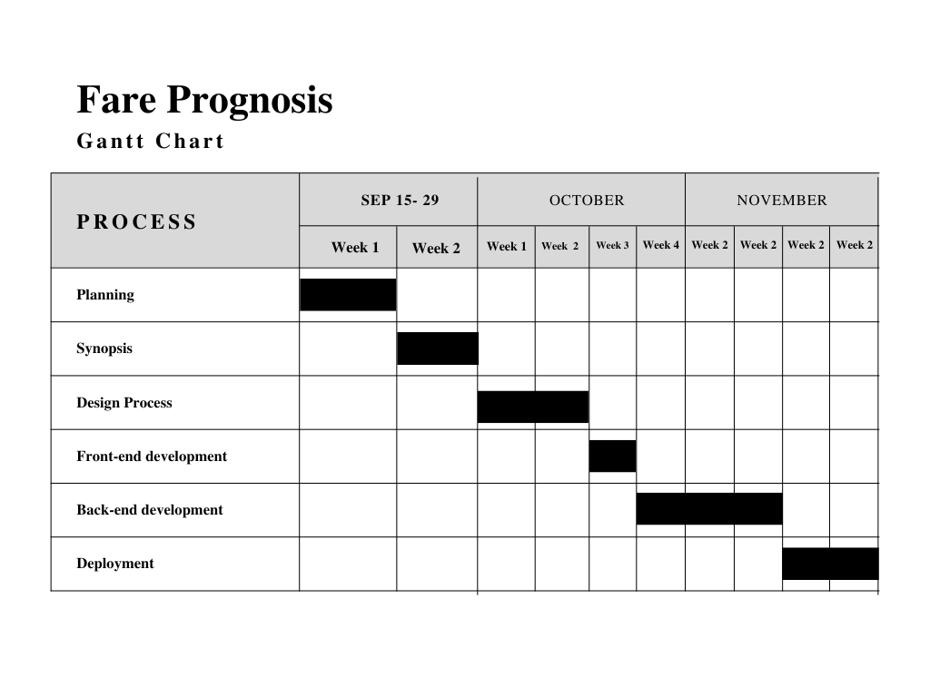

Figure: 1.1 Gantt chart (Progress Report)

**Below data science concepts are used in this project**

Some methods are used for price prediction :-

* Linear regression.
* Region regression.
* Lasso regression.
* Decision tree.
* SVM.
* Random forest.
* Extra trees.
* Gradient boost.

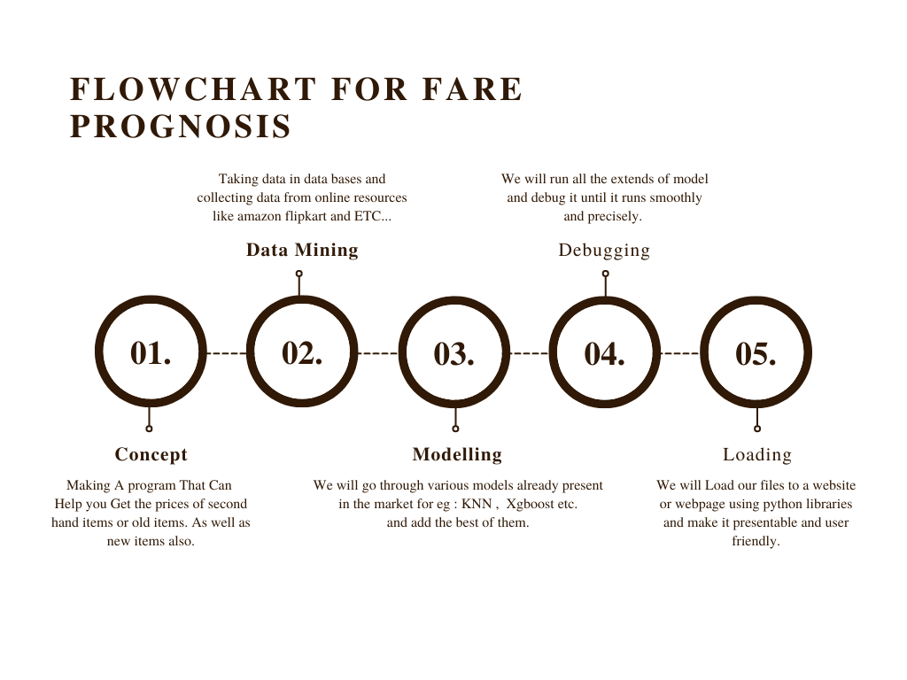Data loading and cleaningOutlier detection and removalWeb Site Designing



Figure: 1.2 Flowchart chart

**CHAPTER 3**

**IMPLEMENTATION**

**3.1 SYSTEM REQUIREMENT:**

In order to use it effectively and efficiently, every system software need certain hardware component or the

software requirement to be made available on the computer. To ensure proper installation and usability of the

new system, the following must be taken into consideration:

3.1.1 Hardware Requirements :

Processor: Minimum 1 GHz; Recommended 2GHz or more.

Ethernet connection (LAN) OR a wireless adapter (Wi-Fi)

Hard Drive: Minimum 32 GB; Recommended 64 GB or more.

Memory (RAM): Minimum 1 GB; Recommended 4 GB or above.

**3.1.2 Software Requirements :**

Numpy and Pandas for data cleaning

Matplotlib for data visualization

Skill learn for model building

Google Collaboratory Notebook

Python flask for HTTP server

HTML/CSS/JavaScript for UI

IDE’s:VS code and Google Colab.

**CHAPTER 4**

**TESTING/RESULT AND ANALYSIS**

**4.1 Analysis:**

This is the process of confirming whether the new system is working according to the specification. Testing and

tails are pertinent in this system, because it will minimize or eliminate the errors in an online shopping system.

This test will show exactly the type of problems develop in the system in the processing of data and would also indicate any problem in the respond time of the system. The process of testing the system is to defect errors and debug them before it is delivered, installed and made operational errors including bugs that cause system not to

work according to specifications.

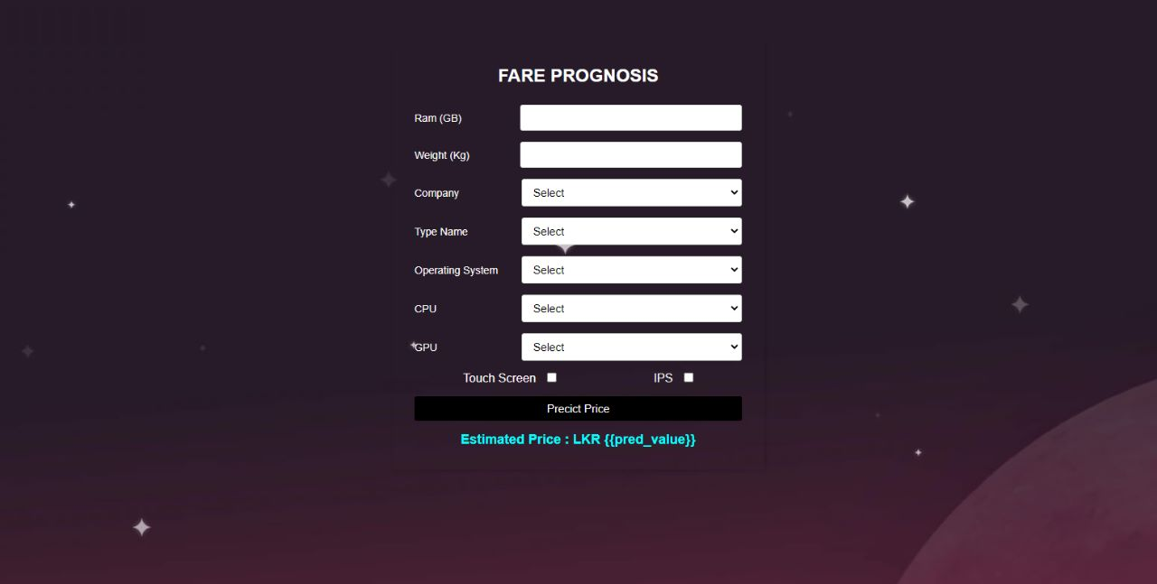

Image: 4.1 Website

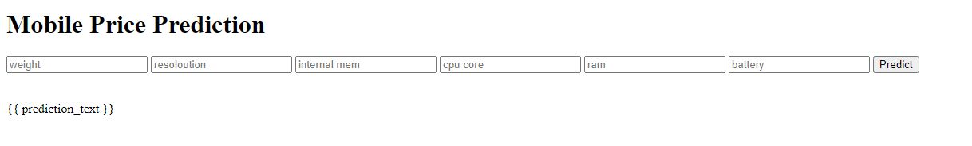

Image: 4.2 Testing

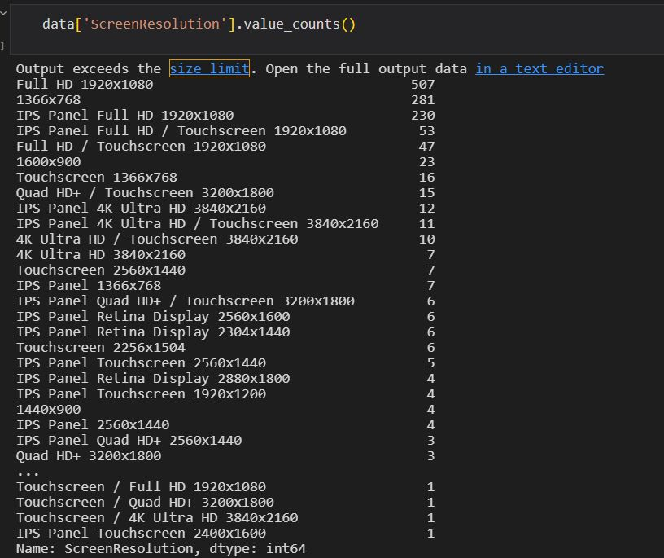

Image: 4.3 Data

**CHAPTER 5**

**CONCLUSION**

From curating the idea to designing the product our team went through a lot of challenges that shaped and

cultivated our mind towards structural thinking. the designing phase taught us a lot about team work, managing

an idea and eventually executing it on time.

We all adopted new and effective ways of solving the problems may it be related to hard-end coding, or keeping

up the pace as a whole team. we learned about structural thinking which is all about breaking up the problem

into smaller buckets rather than dealing with the whole of it altogether. this prompted us even more to reach the

end product of our project.

**REFERENCES**

[1] Model “BANGALORE PRICE PREDICTION MODEL”

[2] Heroku “Documentation”

[3] Repository: “Web Application” <https://github.com/msatmod/Bangalore-House-Price-Prediction>

[4] Repository: “Web Application” <https://github.com/Amey-Thakur/BANGALORE-HOUSE-PRICE-PREDICTION>

[5] Pickle ‘’Documentation’’

[6] A. Varma, A. Sarma, S. Doshi and R. Nair, " Price Prediction Using Machine Learning and Neural Networks," 2018 Second International Conference on Inventive Communication and Computational Technologies (ICICCT), 2018, pp. 1936-1939, doi: 10.1109/ICICCT.2018.8473231.

[7] Furia, Palak, and Anand Khandare. "Real Estate Price Prediction Using Machine Learning Algorithm." e-Conference on Data Science and Intelligent Computing. 2020.

[8] Musciano, Chuck, and Bill Kennedy. HTML & XHTML: The Definitive Guide: The Definitive Guide. " O'Reilly Media, Inc.", 2002.

[9] Aggarwal, Shalabh. Flask framework cookbook. Packt Publishing Ltd, 2014.

[10] Grinberg, Miguel. Flask web development: developing web applications with python. " O'Reilly Media, Inc.", 2018.

[11] Middleton, Neil, and Richard Schneeman. Heroku: up and running: effortless application deployment and scaling. " O'Reilly Media, Inc.", 2013